MYSQL TASK
Table Creation and Data loaded
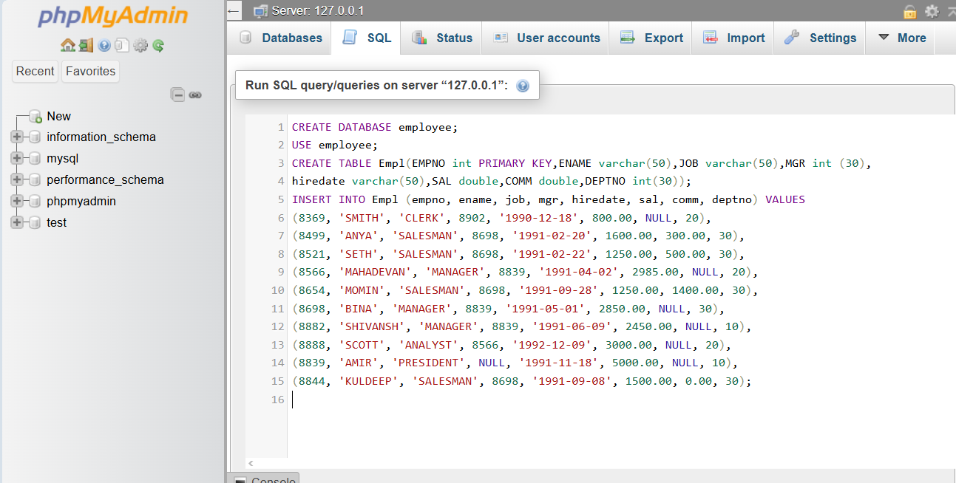
QUERY:

OUTPUT:
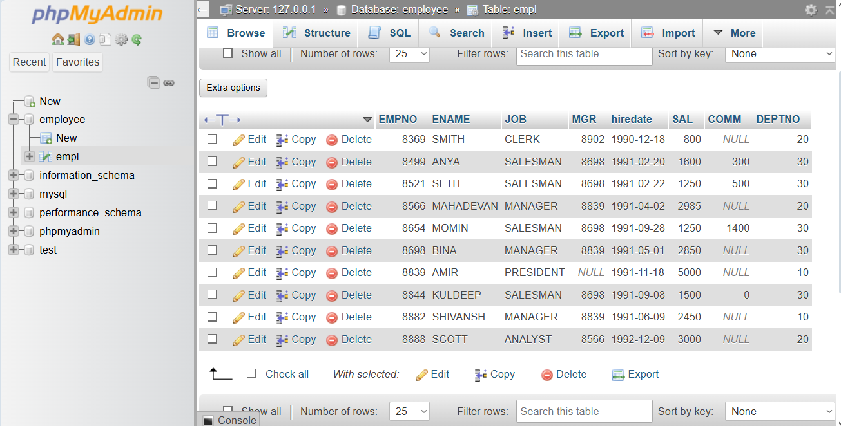

Write a query to display Ename and sal of employees whose salary are greater than or equal to 2200
QUERY:
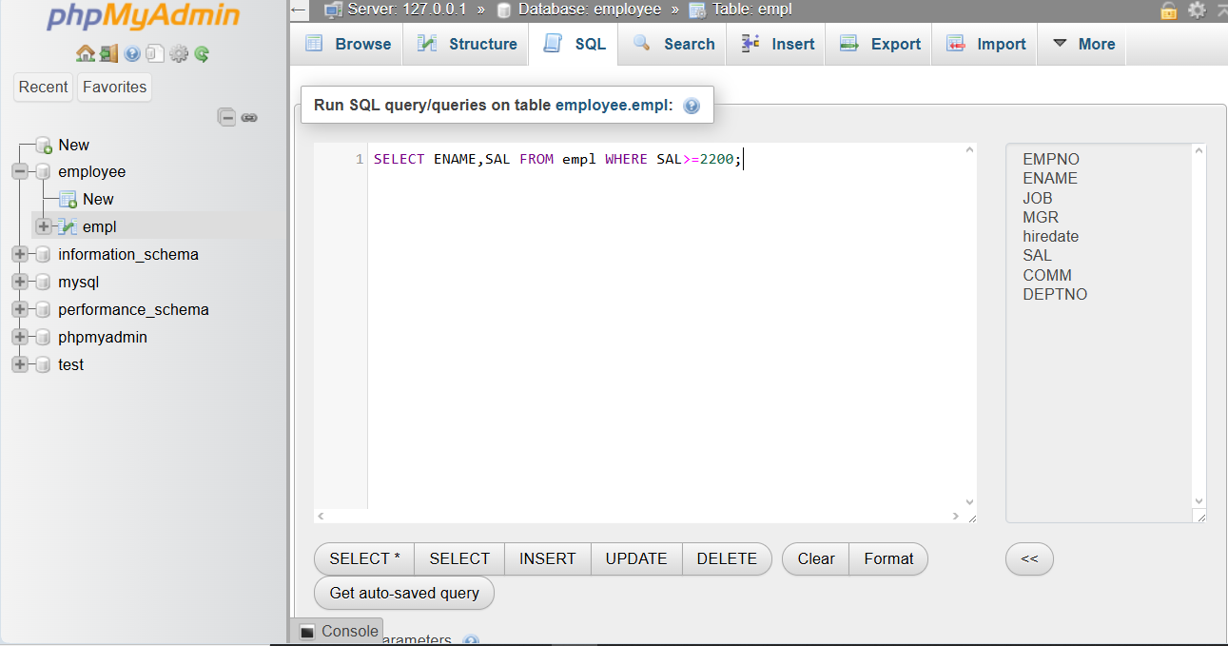

OUTPUT:

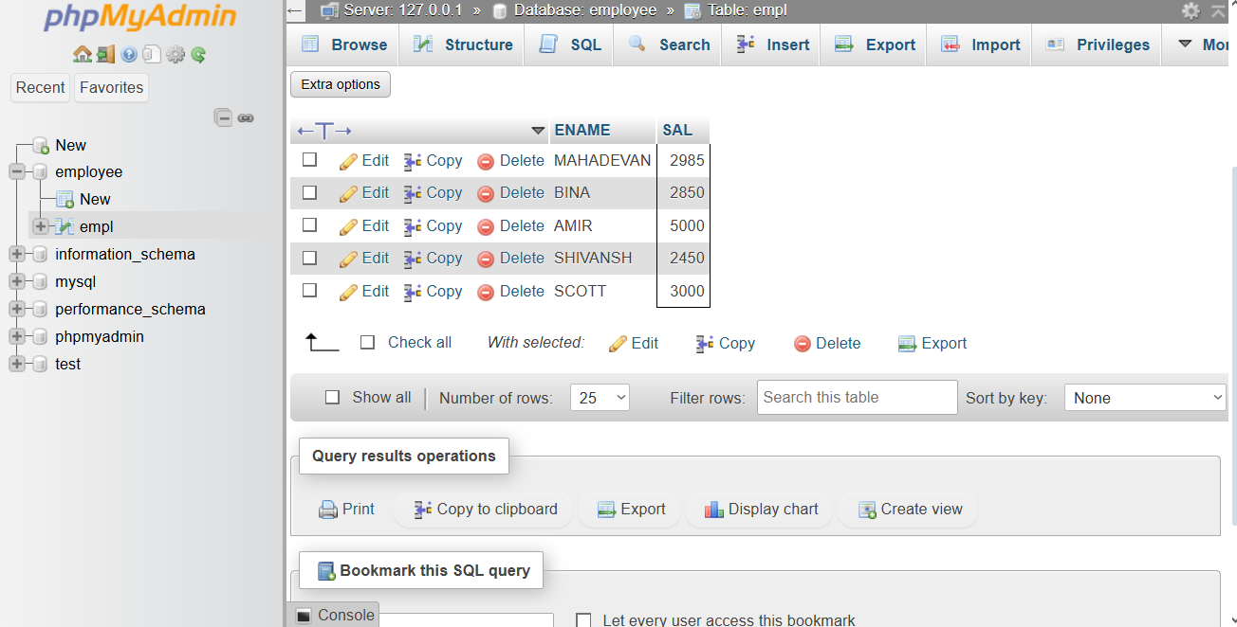

Write a query to display details of employees who are not getting commission
QUERY:

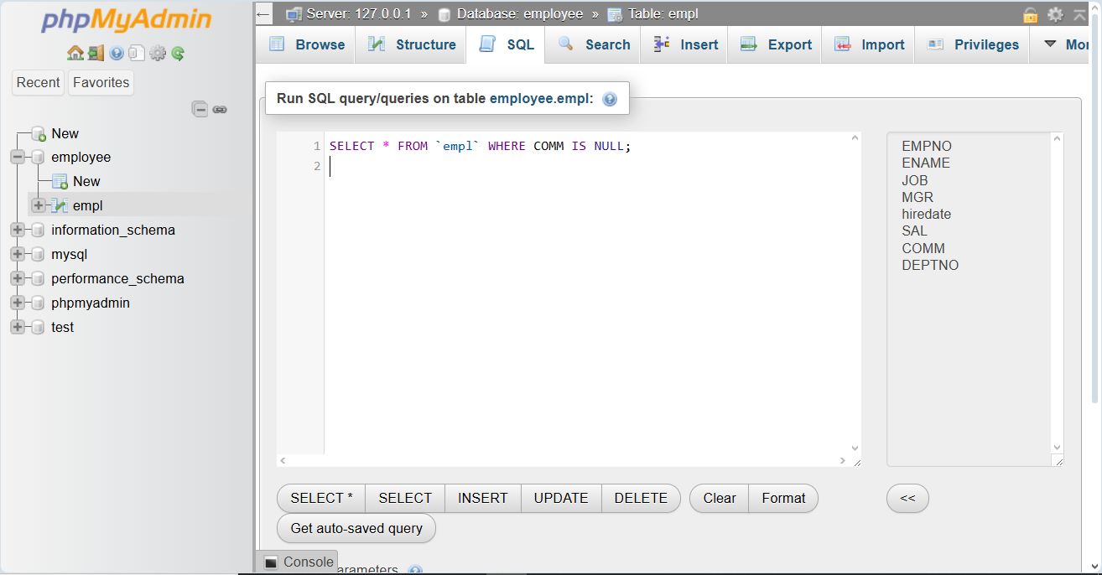
OUTPUT:
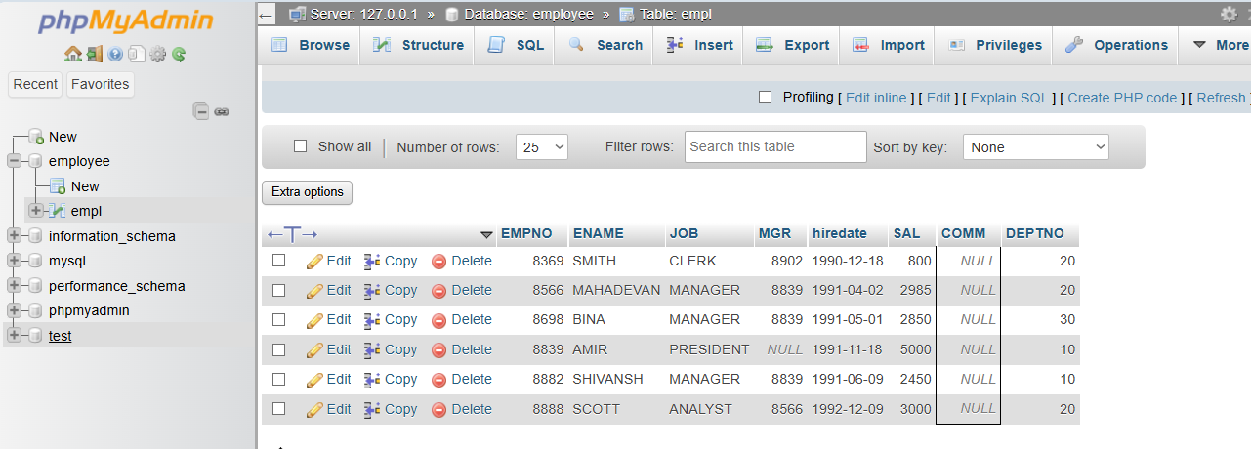

Write a query to display employee name and salary of those employees who don’t have their salary in the range of 2500 to 4000
QUERY:
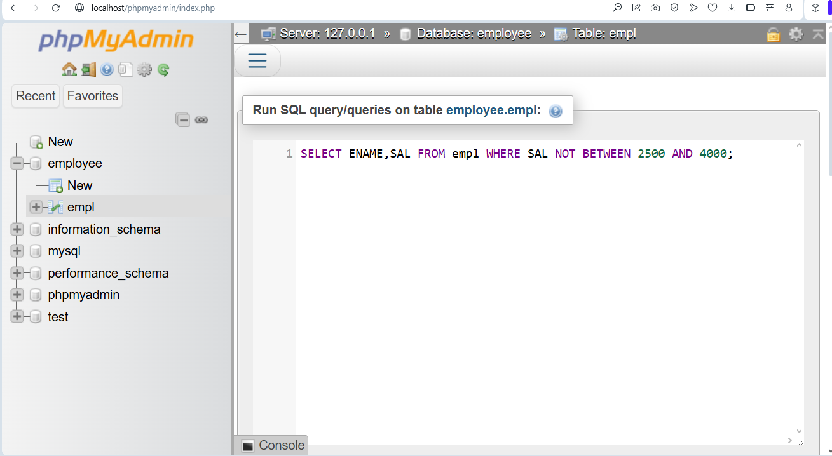
OUTPUT:

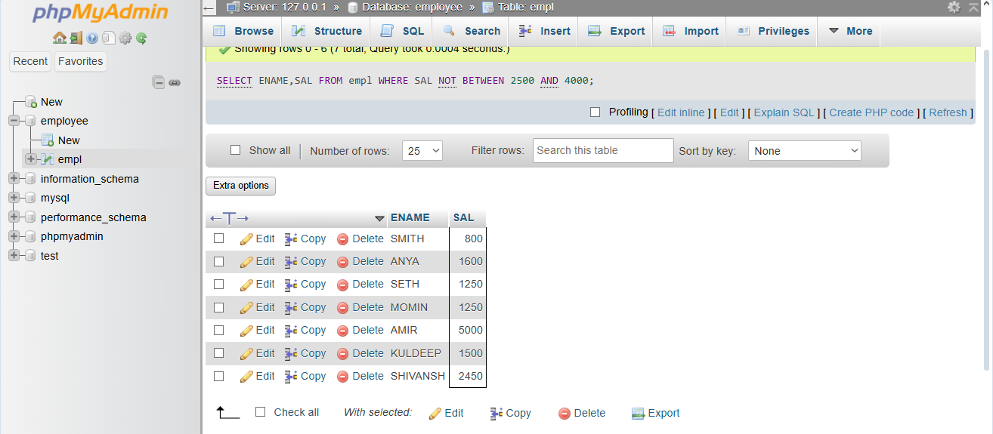

Write a query to display the name, job title and salary of employees who don’t have a manager
QUERY:
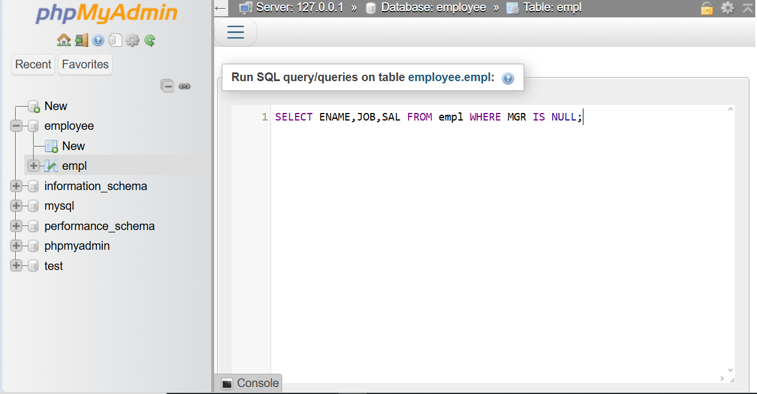

OUTPUT:
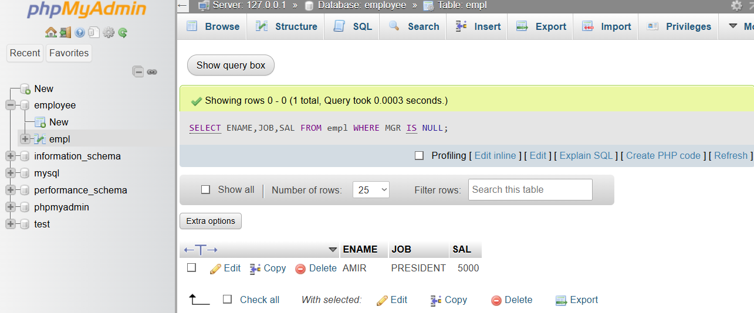

Write a query to display the name of an employee whose name contains “A” as third alphabet
QUERY:

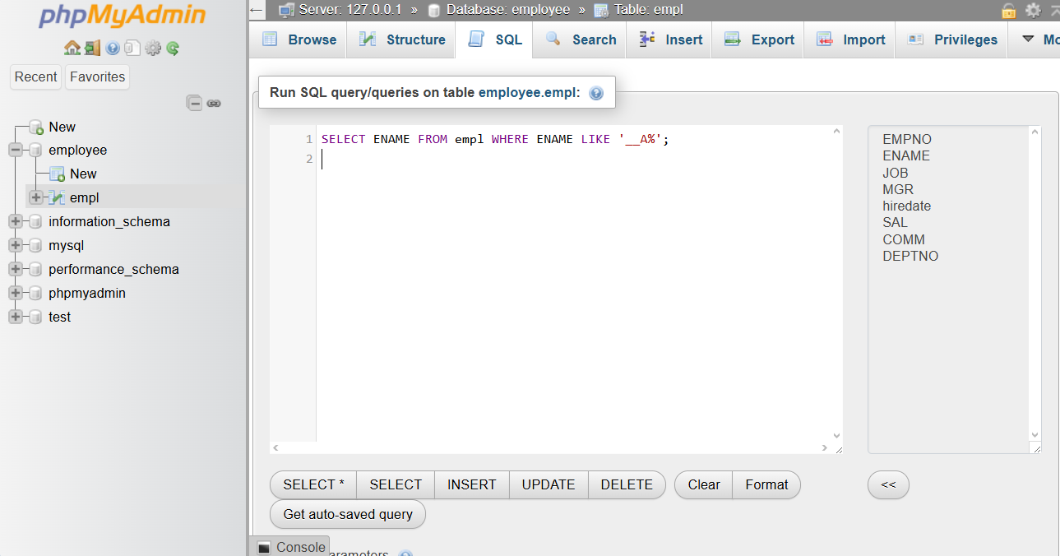

OUTPUT:

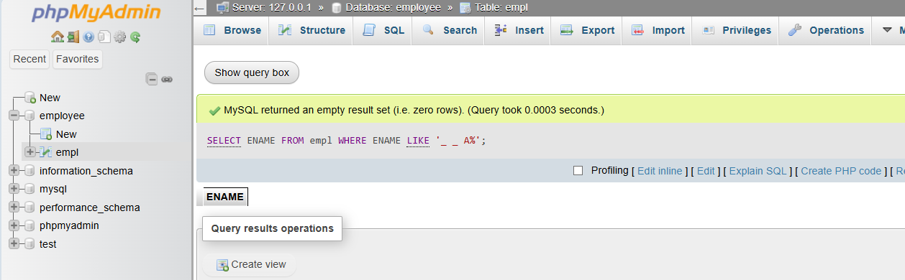

Write a query to display the name of an employee whose name contains “T” as the last alphabet
QUERY:

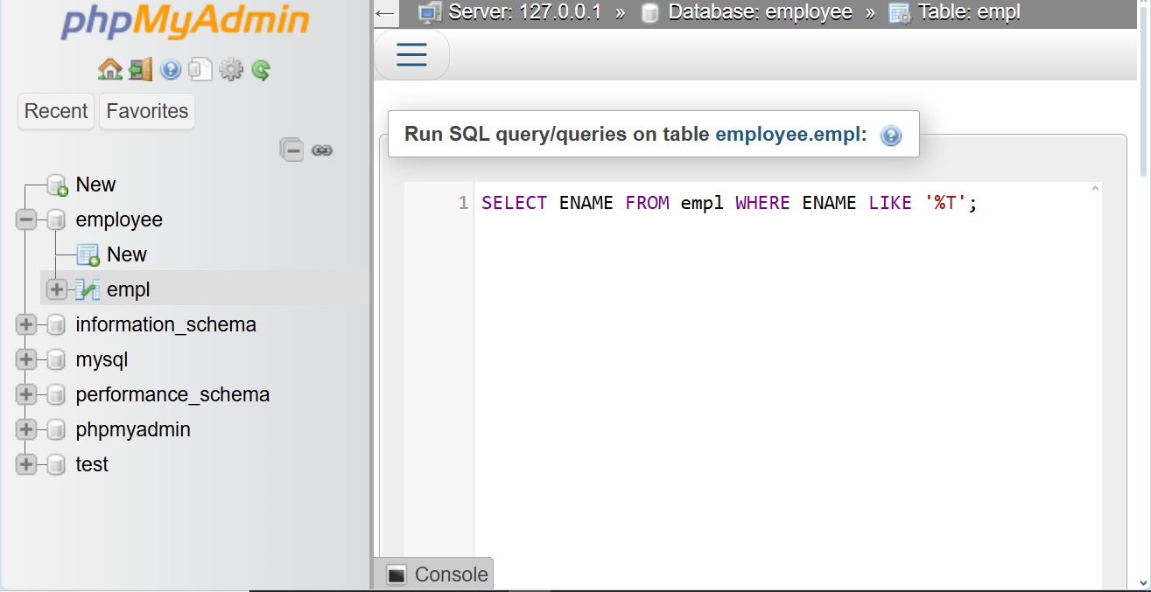
OUTPUT:
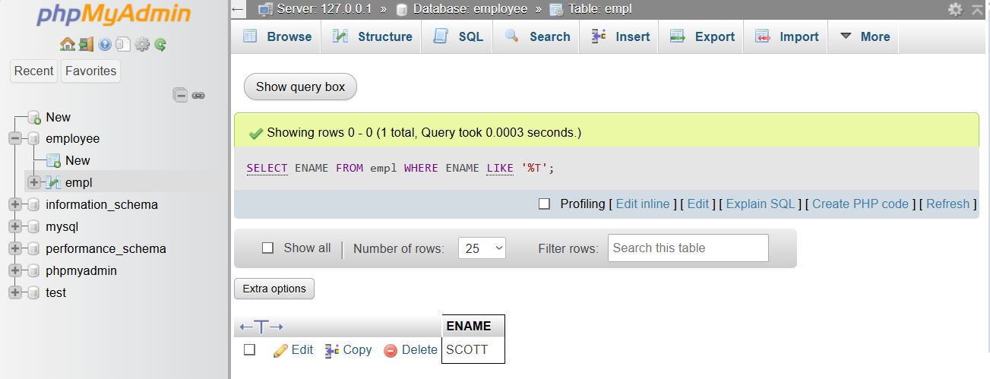

SQL STATEMENT:

CREATE TABLE EMPL (
EMPNO INT PRIMARY KEY,
ENAME VARCHAR(50),
JOB VARCHAR(50),
MGR INT(50),
HIREDATE VARCHAR(50),
SAL DOUBLE,
COMM DOUBLE,
DEPTNO INT(30)
);

INSERT INTO empl (EMPNO, ENAME, JOB, MGR, HIREDATE, SAL, COMM, DEPTNO) VALUES
(8369, 'SMITH', 'CLERK', 8902, '1990-12-18', 800.00, NULL, 20),
(8499, 'ANYA', 'SALESMAN', 8698, '1991-02-20', 1600.00, 300.00, 30),
(8521, 'SETH', 'SALESMAN', 8698, '1991-02-22', 1250.00, 500.00, 30),
(8566, 'MAHADEVAN', 'MANAGER', 8839, '1991-04-02', 2985.00, NULL, 20),
(8654, 'MOMIN', 'SALESMAN', 8698, '1991-09-28', 1250.00, 1400.00, 30),
(8698, 'BINA', 'MANAGER', 8839, '1991-05-01', 2850.00, NULL, 30),
(8882, 'SHIVANSH', 'MANAGER', 8839, '1991-06-09', 2450.00, NULL, 10),
(8888, 'SCOTT', 'ANALYST', 8566, '1992-12-09', 3000.00, NULL, 20),
(8839, 'AMIR', 'PRESIDENT', NULL, '1991-11-18', 5000.00, NULL, 10),
(8844, 'KULDEEP', 'SALESMAN', 8698, '1991-09-08', 1500.00, 0.00, 30);

SELECT ENAME, SAL FROM empl WHERE SAL >= 2200;
SELECT * FROM empl WHERE COMM IS NULL;
SELECT ENAME, SAL FROM empl WHERE SAL NOT BETWEEN 2500 AND 4000;
SELECT ENAME, JOB, SAL FROM empl WHERE MGR IS NULL;
SELECT ENAME FROM empl WHERE ENAME LIKE '__A%';
SELECT ENAME FROM empl WHERE ENAME LIKE '%T';

